Dominique White
Linux and Virtualization Tech
Professor Monica Fyfe
Saturday, October 18, 2025

Milestone 1: Create an EC2 Server
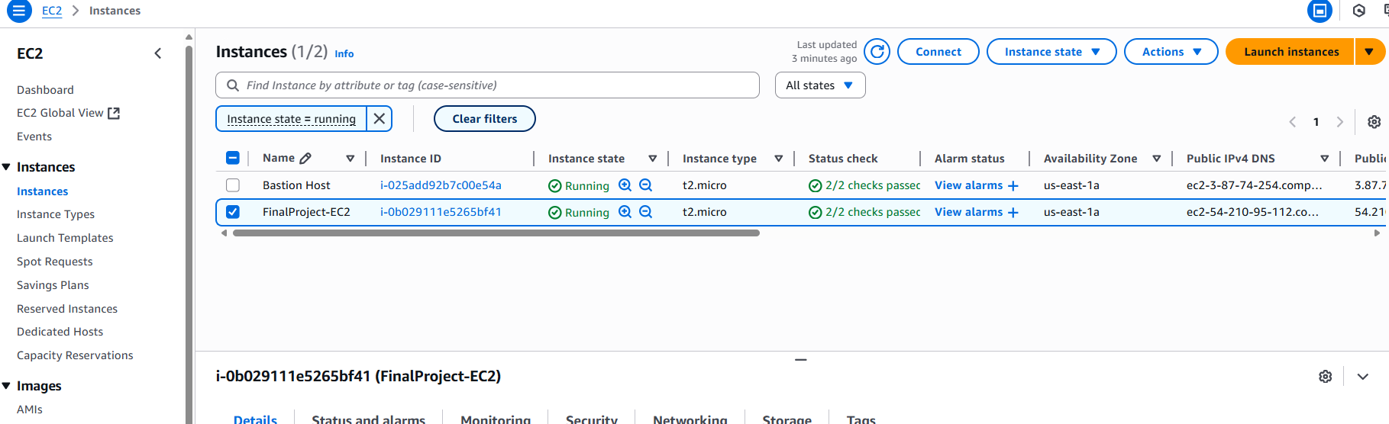
EC2_Running

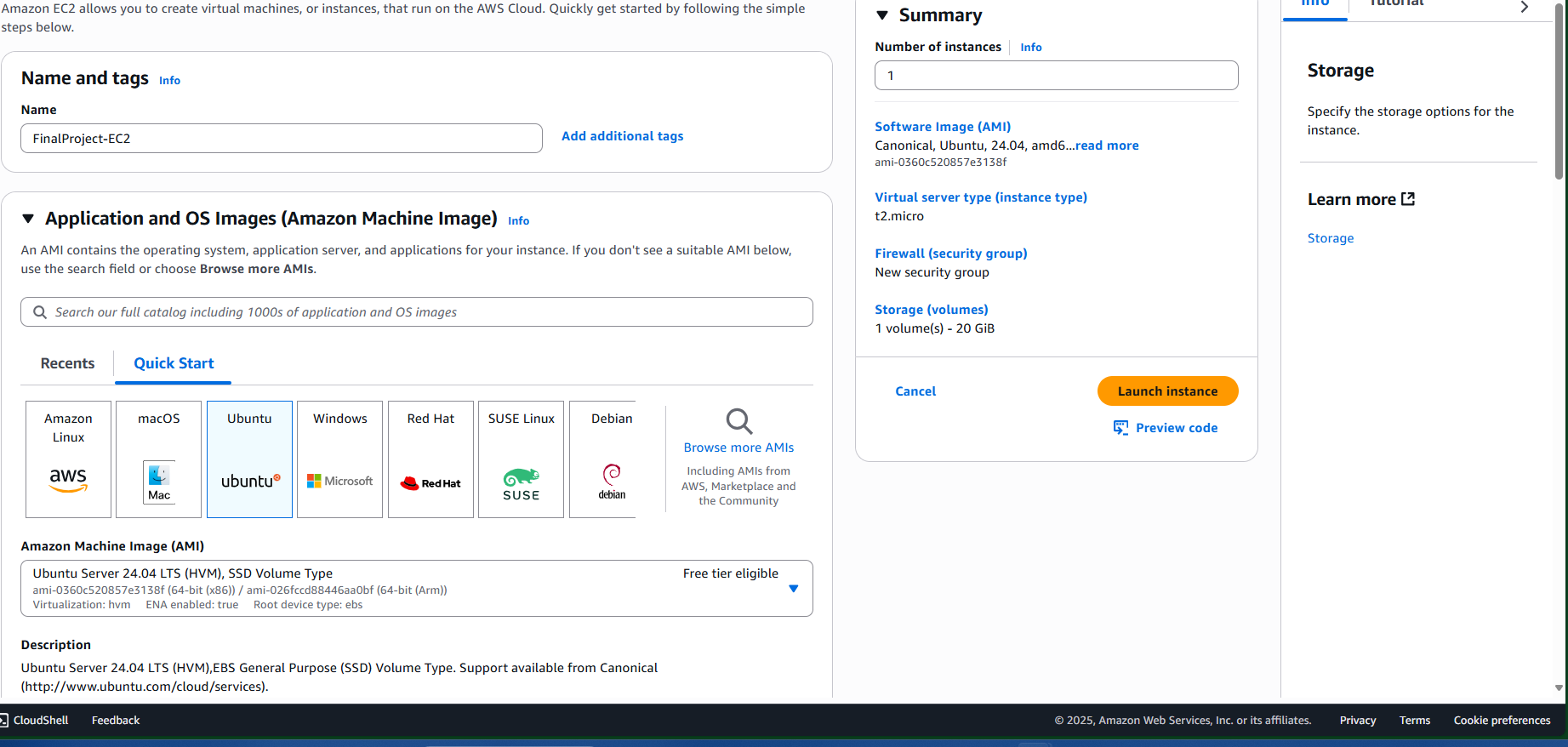 EC2_BeforeLaunch

Milestone 2: Securing the Server
EC2 Instance Summary
The EC2 instance was launched using the AWS Academy Learner Lab environment.
- Instance Type: t2.micro
- AMI: Amazon Linux 2023
- Key Pair: dom_keypair.pem
- Security Group: SSH access (port 22) restricted to my IP
- Storage: 8 GB General Purpose SSD
- Purpose: To host shell scripts and automation tools for academic testing and project validation
Purpose of IAM Account
IAM (Identity and Access Management) is essential for securing AWS environments. It allows administrators to:
- Assign granular permissions to users and groups
- Enforce least privileged access to reduce risk
- Replace root account usage with role-based access control
- Enable auditing and accountability through CloudTrail logs
IAM ensures that only authorized users can access specific AWS resources, supporting both security and operational efficiency.
User Account Creation
Two IAM users were created to simulate role-based access:
- teacher_user
  - AWS Console access enabled
  - Permissions: Full access to EC2 and S3
  - MFA enabled for added security
- standard_user
  - AWS Console access enabled
  - Permissions: Read-only access to S3
  - MFA optional
These users represent different access levels for instructors and students.
User Groups & Policies
Two IAM groups were created to manage permissions efficiently:
- Instructor Group
  - Policies attached:
    - AmazonEC2FullAccess
    - AmazonS3FullAccess
  - Purpose: Full control over EC2 and S3 resources for teaching and setup
- Standard Group
  - Policy attached:
    - AmazonS3ReadOnlyAccess
  - Purpose: Limited access for students to view scripts and logs
Using groups simplifies permission management and supports scalable access control.
User-to-Group Assignment
Users were assigned to groups based on their roles:
- teacher_user was added to the Instructor Group
- standard_user was added to the Standard Group
This ensures that each user receives the correct permission without manual policy assignment.
S3 Bucket Setup
An S3 bucket was created to store project files:
- Bucket Name: finalproject-scripts
- Folder: myscripts/
- File: setup_notes.txt (contains EC2 setup instructions)
The bucket was configured with versioning enabled and public access blocked. This ensures secure storage of project-related scripts and documentation.
IAM Web Portal Access
To access the IAM login portal:
- Navigate to the IAM Dashboard
- Locate the IAM users sign-in link
- Copy the custom login URL (e.g., https://your-account-id.signin.aws.amazon.com/console)
- Share this link with IAM users for secure console access
This URL allows users to log in using their IAM credentials without exposing the root account.

Milestone 3: Linux Scripting & Management

This script copies all .txt files from the myscripts folder into a new folder called myscripts_backup.”
#!/bin/bash
# Script Name: copy_myscripts.sh
# Purpose: Copy text files from myscripts folder into a new folder

# Define source and destination
SOURCE_DIR="$HOME/myscripts"
DEST_DIR="$HOME/myscripts_backup"

# Create the destination folder if it doesn’t exist
mkdir -p "$DEST_DIR"

# Copy all .txt files from source to destination
cp "$SOURCE_DIR"/*.txt "$DEST_DIR"

# Print confirmation
echo "All text files from $SOURCE_DIR have been copied to $DEST_DIR"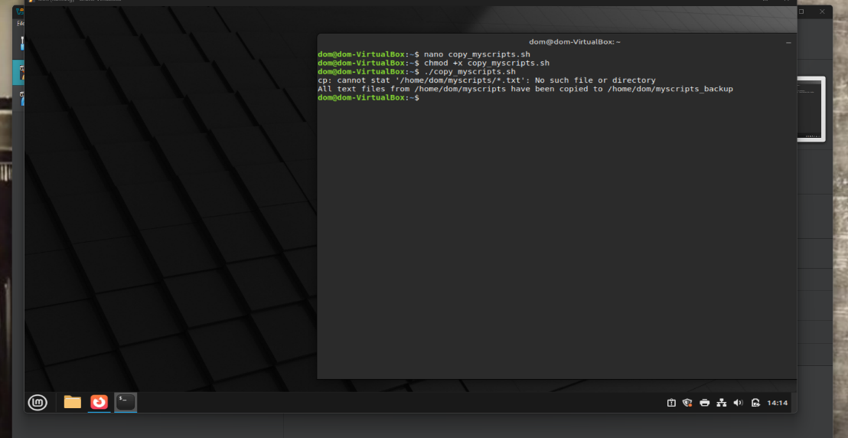

How to create and run a Bash script

Open the terminal. Use nano or vim to write your Bash script. Start with #!/bin/bash, then add commands line by line. Save as myscript.sh. Run chmod +x myscript.sh to make it executable. Run ./myscript.sh to execute.

Benefits of Bash Scripting:

Bash scripting helps manage Linux systems by automating tasks like backups, updates, and file management. Automation saves time and prevents errors. Scripts ensure commands always run the same way. Use cron jobs to schedule scripts and run tasks automatically at set times.

Project Conclusion

This project provided practical experience in cloud administration. I set up an EC2 instance, documented IAM practices, and automated server tasks with Bash scripts—laying a solid foundation in scalable and secure cloud operations.

